AWS S3 Event-Driven Automation Using Lambda

Step 1: Create an S3 Bucket
I logged in to the AWS Management Console and opened Amazon S3. I created a bucket named “lambda-event-day29-10” to store the files that would trigger the automation.
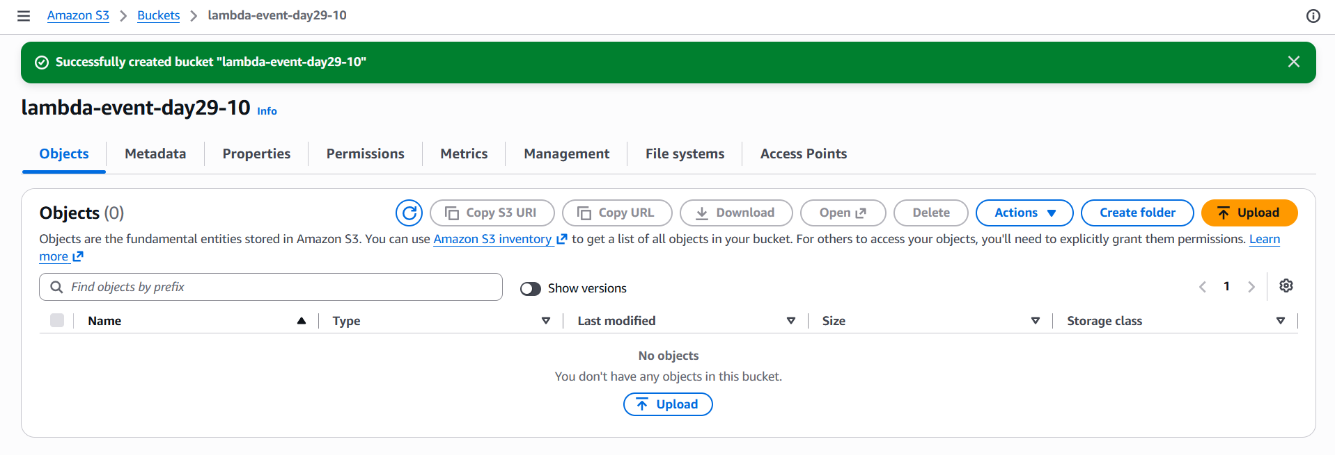

Step 2: Create a Lambda Function
I opened AWS Lambda and created a function named “S3EventDrivenAutomation”. This function contains the Python code that runs when it receives an event from Amazon S3.
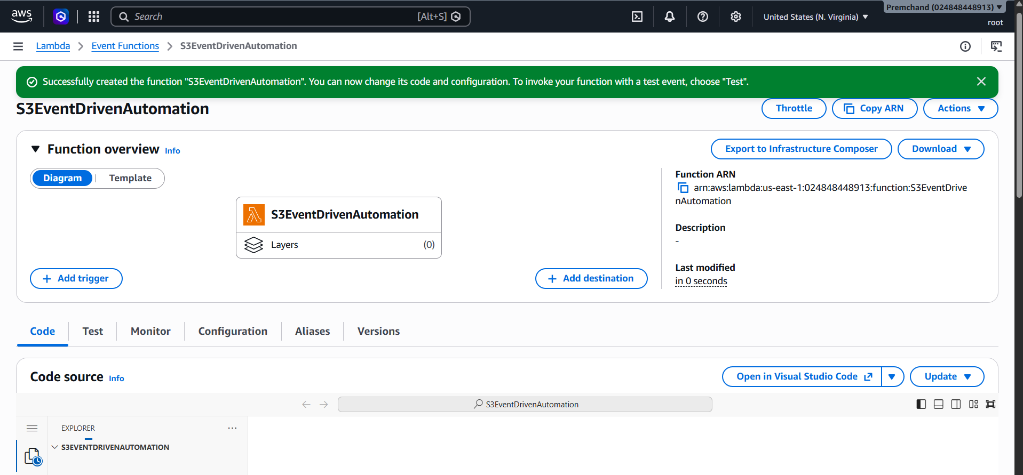

Step 3: Write the Python Code
I added Python code to the Lambda function to process the event received from S3. The code reads the event details, extracts the bucket name and uploaded file name, and prints the event information. It also prints a success message and returns a response indicating that the event was processed.
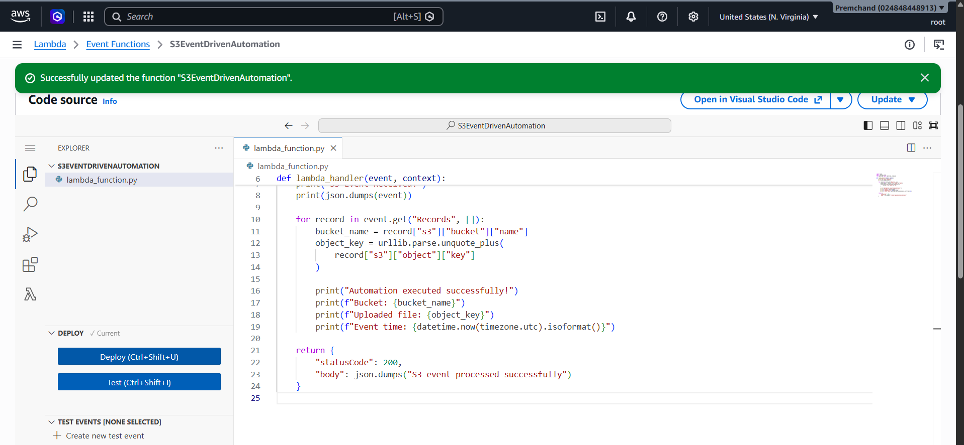

Step 4: Deploy the Lambda Function
After writing the code, I saved and deployed the Lambda function so the updated code was ready to run.

Step 5: Add an S3 Trigger
I added an Amazon S3 trigger to the Lambda function and selected the bucket “lambda-event-day29-10”. This connected the S3 bucket to Lambda so an event from the bucket could invoke the function.
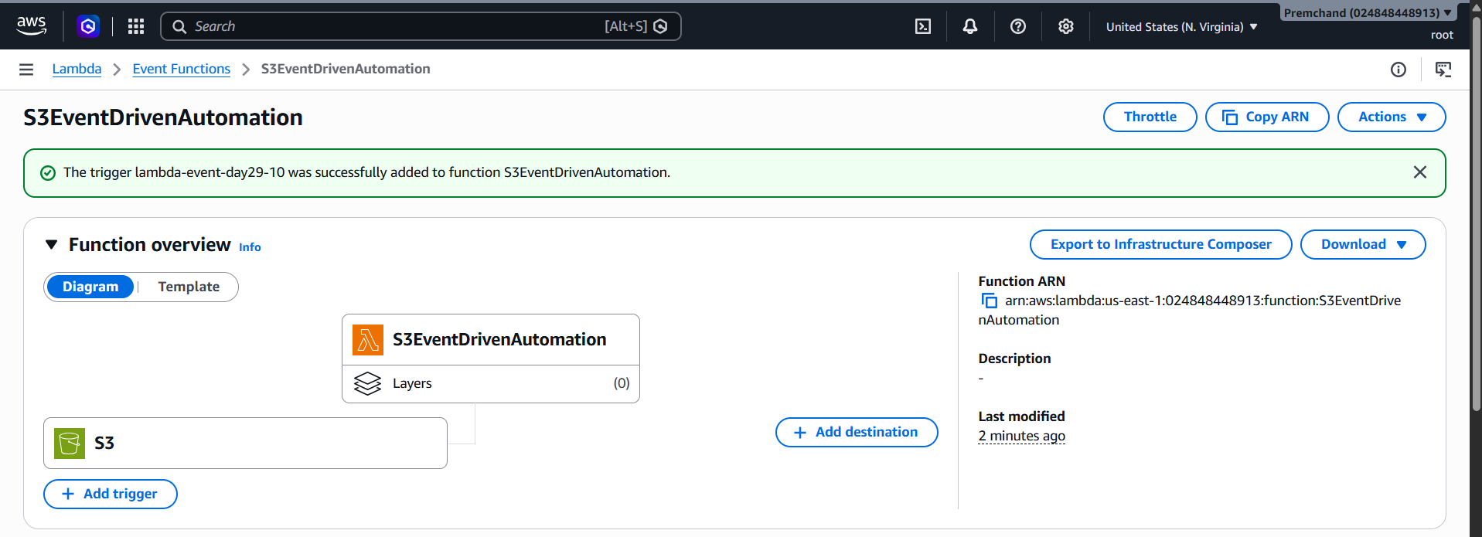

Step 6: Upload a Test File
I opened the S3 bucket and uploaded a file named “test.txt”. The upload status showed that the file was uploaded successfully.
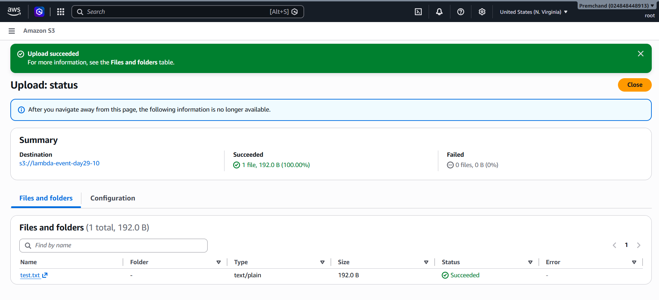

Step 7: Trigger the Lambda Function
After the file was uploaded, Amazon S3 generated an event that invoked the configured Lambda function. The function processed the event and retrieved details such as the bucket name and uploaded file name.

Step 8: Check the Logs in CloudWatch
I opened Amazon CloudWatch and checked the Lambda function logs. The logs showed the event details, the uploaded file information, and the success message. This helped me verify that the function had executed.
